Dikeno Khudu Kgolane
Practical 5: Retail sales (google bigquery)

WHERE Clause
Q1. Filter all transactions that occurred in the year 2023
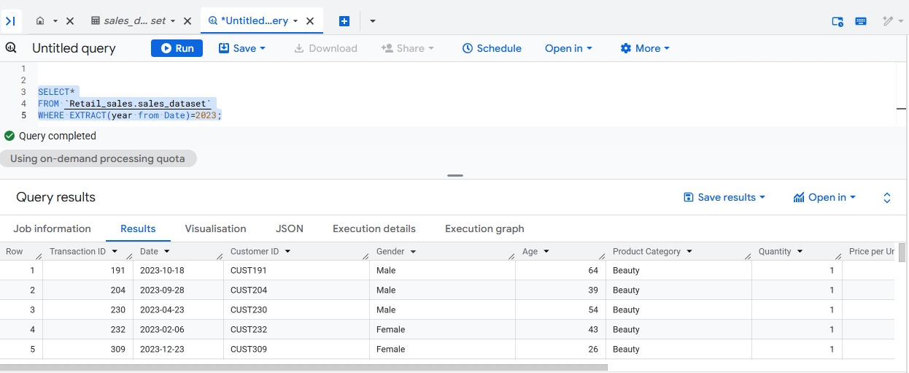
Filtering + Conditions
Q2. Display all transactions where the Total Amount is more than the average Total Amount of the entire dataset.
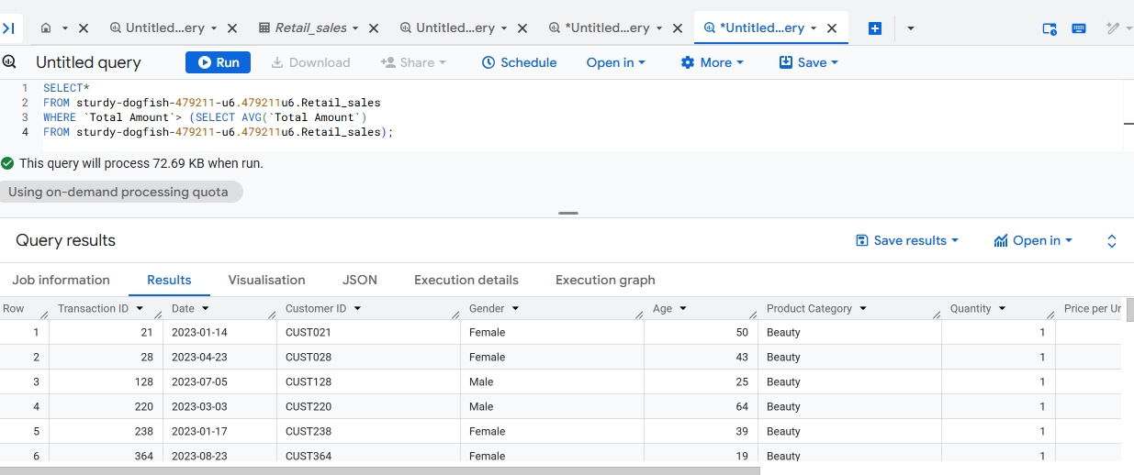
Aggregate Functions
Q3. Calculate the total revenue (sum of Total Amount).
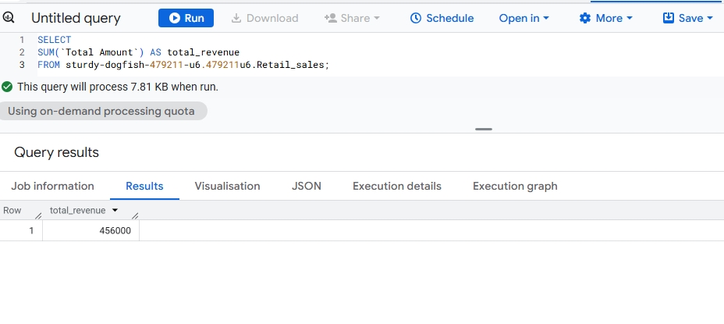
DISTINCT
Q4. Display all distinct Product Categories in the dataset
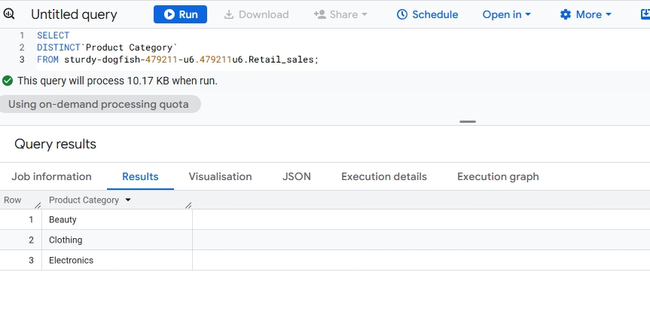
GROUP BY
Q5. For each Product Category, calculate the total quantity sold.
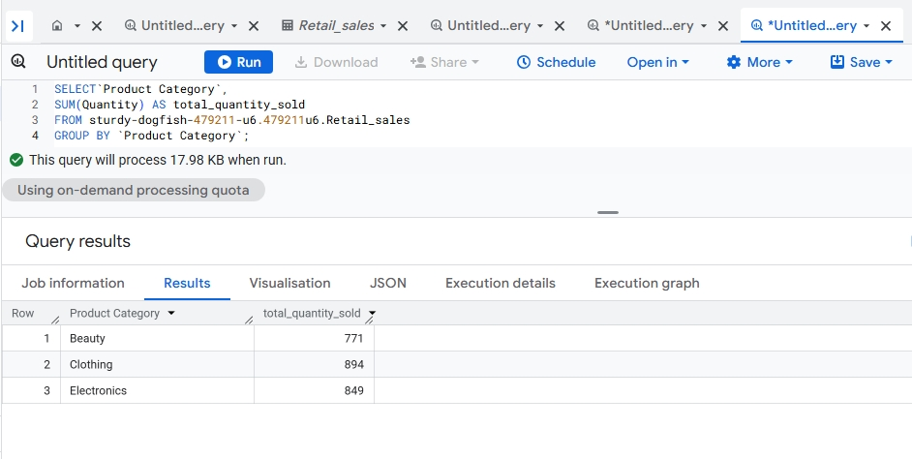
CASE Statement
Q6. Create a column called Age_Group that classifies customers as ‘Youth’ (>30) , ‘Adult’ (30–59), and ‘Senior’ (60+).
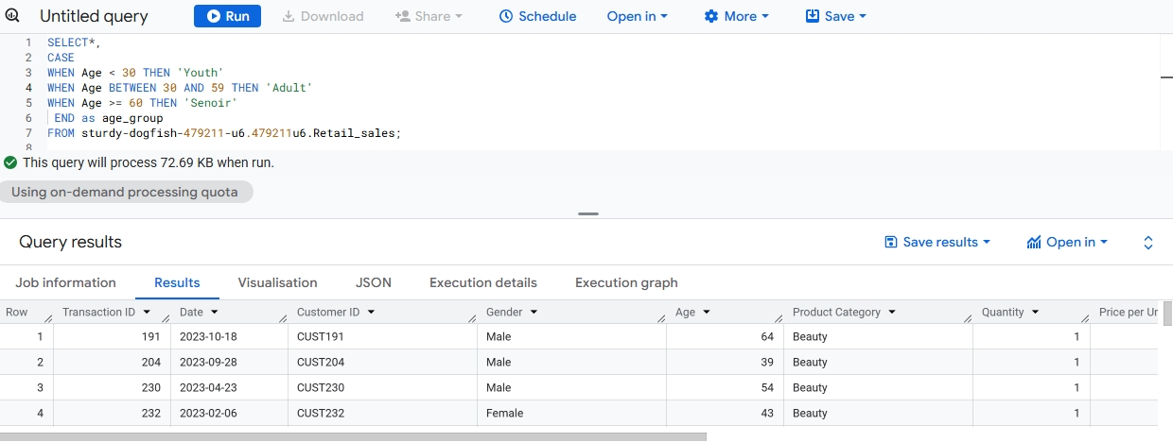

Conditional Aggregation
Q7. For each Gender, count how many high-value transactions occurred (where Total Amount > 500).
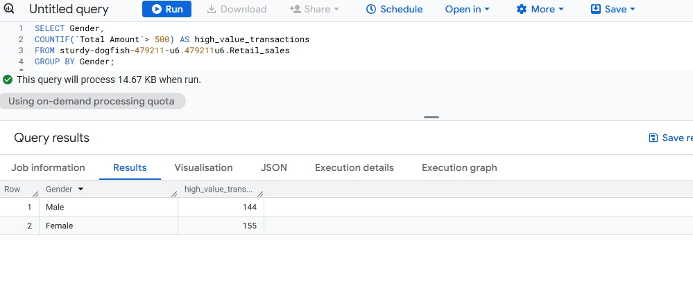
HAVING Clause
Q8. For each Product Category, show only those categories where the total revenue exceeds 5,000.
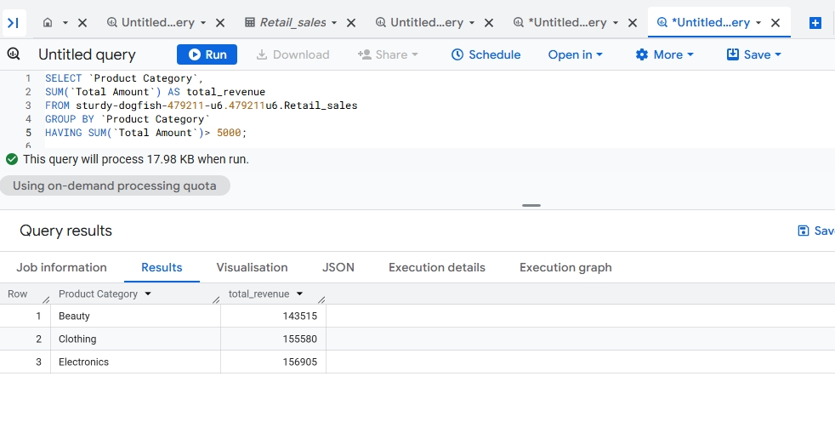
Calculated Fields
Q9. Display a new column called Unit_Cost_Category that labels a transaction as: – 'Cheap' if Price per Unit < 50 – 'Moderate' if Price per Unit between 50 and 200 – 'Expensive' if Price per Unit > 200
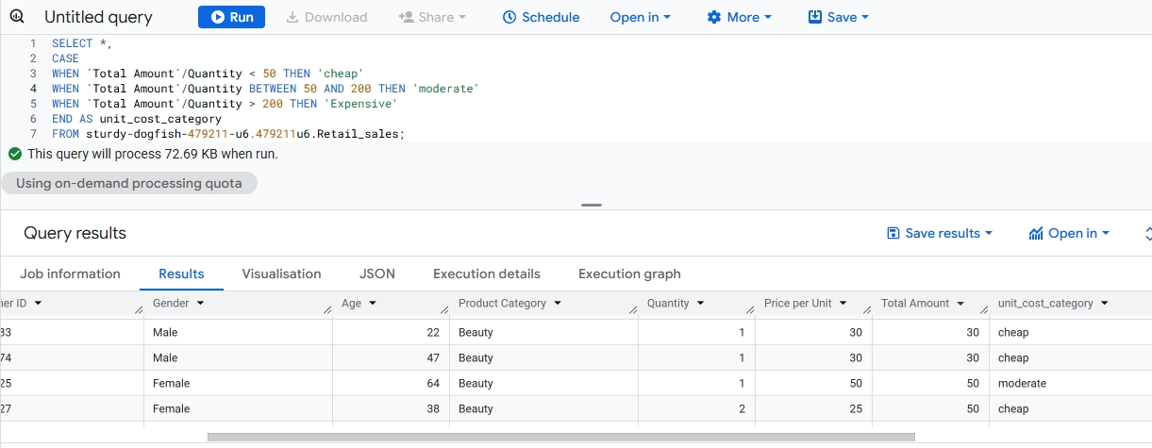
Combining WHERE + CASE
Q10. Display all transactions from customers aged 40 or older and add a column Spending_Level showing ‘High’ if Total Amount > 1000, otherwise ‘Low’.
